**Choose a correct answer accordingly.**

1. A passive network is one which contains:
2. Only variable resistance
3. Only some sources of e.m.f. in it
4. Only two sources of e.m.f. in it
5. **No source of e.m.f. in it**
6. Which of the following is not the properties of transfer function?
7. all initial conditions of the system are set to zero
8. The transfer function is dependent on the input of the system
9. It is defined only for a linear time-invariant system
10. The transfer function between an input variable and an output variable of a system is defined as the Laplace transform of the impulse response
11. The poles and zeros of driving point impedance function and driving point admittance function lie on
12. Left half of s-plane
13. Right half of s-plane
14. Left half of s-plane or on imaginary axis
15. Right half of s-plane or imaginary axis
16. In non-linear network does not satisfy
    1. Superposition condition
    2. Homogeneity condition
    3. Both homogeneity and superposition condition
    4. Homogeneity, superposition and associative condition
17. Which of the following is true about band stop filters?
    * 1. Obtained by parallel connection of low pass and high pass filters.
      2. Obtained by cascade connection of low pass and high pass filters.
      3. Cut off frequency of high pass filter must be less than low pass filter.
      4. All
18. A filter that passes all frequencies lying outside a certain range, while it attenuates all frequencies between the two designated frequencies is called?
19. low pass filter
20. high pass filter
21. band elimination filter
22. band pass filter
23. According to routh tabulation method, the system is said to be stable if there are no sign changes in the first column of the routh array, the number of poles lies on the left half of s-plane =number of sign changes.
24. True
25. False
26. For the Reciprocity Theorem to satisfy the ratio of response to excitation before and after the source is replaced should be?
27. Different
28. Same
29. before source is replaced is greater than after the source is replaced
30. before source is replaced is less than after the source is replaced
31. Which one the following true about symmetry theorem for the two port electrical networks.
32. For z parameters open circuit driving point impedance must be equal to be symmetrical network.
33. For Y parameters short circuit driving point admittance must be equal to be symmetrical network.
34. For h and g parameters determinants of corresponding h and g parameters must be equal to 1 to be symmetrical network.
35. All the above
36. A network either T or π, is said to be of the constant-k type if Z1 and Z2 of the network satisfies the relation?
37. Z1Z2 = k
38. Z1Z2 = k2
39. Z1Z2 = k3
40. Z1Z2 = k4
41. Determine the range of **K** so that the system given by characteristic equation. is stable.
42. K < -5.253
43. K > 0.2537
44. K > 0.528
45. K < -2.525
46. The driving point impedance of a one-port reactive network is given by . After taking the partial fractions, find the coefficient of 1/s.
47. 25/4
48. 50/4
49. 100/4
50. **125/4**
51. Consider the polynomial The given polynomial P (s) is Hurwitz.
52. True
53. False
54. Determine the driving point impedance **Y11 (S)** in the circuit shown below.

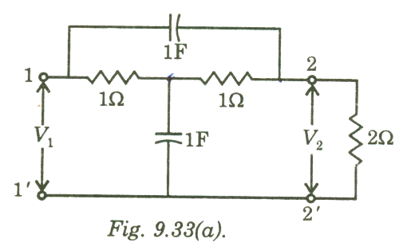

1. 
2. 
3. 
4. 
5. Obtain the current transfer ratio  of the network shown below.

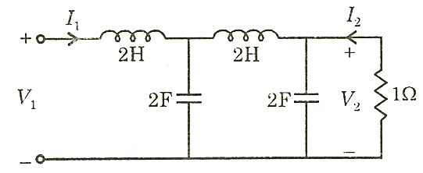

1. 
2. 
3. 
4. 
5. For the circuit given below, the value of Transmission parameter A and C are ____________

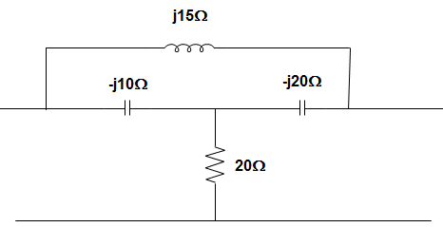

* 1. A = -0.7692 + j0.3461 Ω, C = 0.03461 + j0.023 Ω
  2. A = 0.7692 + j0.3461 Ω, C = 0.03461 + j0.023 Ω
  3. A = -0.7692 – j0.3461 Ω, C = -0.03461 + j0.023 Ω
  4. A = 0.7692 – j0.3461 Ω, C = 0.023 + j0.03461 Ω

1. The dependent source in Figure below is:

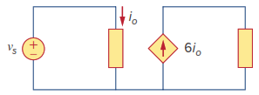

* 1. Voltage-controlled current source
  2. Voltage-controlled voltage source
  3. Current-controlled voltage source
  4. Current-controlled current source

1. If the current in an electric conductor is 2.4 A, how many coulombs of charge pass any point in a 30-second interval?
2. 7.2 C
3. 72 C
4. 7.2mC
5. 72mC
6. After 10.61 x 1013 electrons are added to a metal plate, it has a negative charge of 3µC. What was its initial charge in coulombs?
7. +14 µC
8. -14 µC
9. +17 µC
10. -17 µC
11. A network has 16 branches and 9 independent loops. How many nodes are there in the network?
12. 19
13. 5
14. 8
15. 4
16. Which of the circuits in Figure below will give you Vab =​7​V?
17. 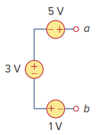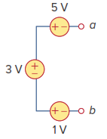 c.

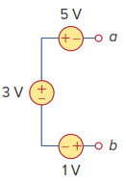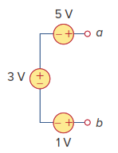

1. d.
2. A resistor R is connected in series with a parallel circuit comprising two resistances of 12 Ω and 8 Ω. The total power dissipated in the circuit is 700 watts when the applied voltage is 200 V. calculate the value of R.
3. 15 Ω
4. 25.34 Ω
5. 52.34 Ω
6. 30.34 Ω
7. 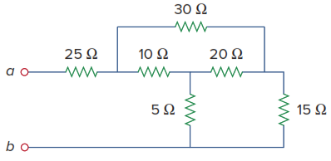What will be the equivalent resistance at the terminals a-b for the below circuit
8. 11.25 Ω
9. 25 Ω
10. 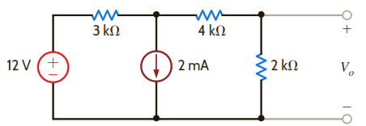36.25 Ω
11. 31.5 Ω
12. Compute Vo in the below circuit
13. 2.67 V
14. 1.80 V
15. -1.33 V
16. 1.33 V
17. 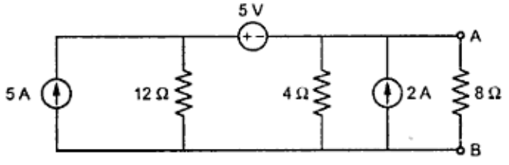The Thevenin resistance at terminals A and B and The Thevenin voltage across terminals A and B of the circuit below is
18. Rth = 16 Ω and Vth = 5 V
19. Rth = 3 Ω and Vth = 19.74 V
20. Rth = 4 Ω and Vth = 5 V
21. Rth = 12 Ω and Vth = 16 V
22. 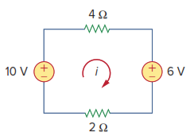The current i in the circuit shown below is:
23. −2.667 A
24. −0.667 A
25. 0.667 A
26. 2.667 A
27. 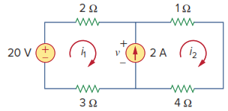For the circuit shown below, current i1 is:
28. 4 A
29. 3 A
30. 2 A
31. 1 A
32. A load is connected to a network. At the terminals to which the load is connected, RTh = 10 Ω and VTh = 40 V. The maximum possible power supplied to the load is:
33. 160 W
34. 80 W
35. 40 W
36. 1 W
37. 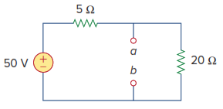The Norton current at terminals a and b of the circuit shown below is:
38. 10 A
39. 2.5 A
40. 5 A
41. 0 A
42. For the below figure, what will be the value of the voltage VA

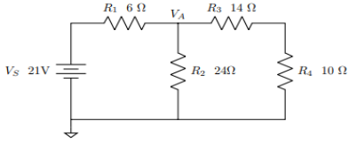

1. 84 V
2. 6 V
3. 24 V
4. 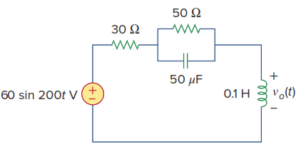14 V
5. Calculate vo(t) in the circuit shown below
6. 20<900
7. 14.14<450
8. 17.14<900
9. 17.14<-900
10. In a certain series resonant circuit, VC = 150 V, VL= 150 V, and VR= 50 V. The value of the source voltage is
11. 150 V
12. 300 V
13. 350 V
14. 50 V
15. 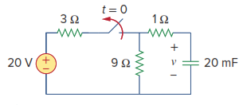The switch in the circuit in below Figure has been closed for a long time, and it is opened at t = 0. Find v(t) for t ≥ 0.
16. 15 V
${15e}^{-5t}$

${15e}^{-0.2t}$

17. 0 V
18. If the load impedance is 20 − j20, the power factor is
$\left\langle -45\right.$

20. 0
21. 1
22. 0.7071
23. What is a digital-to-analog converter?
24. It stores digital data on the computer.
25. It converts alternating current (AC) into direct current (DC).
26. It converts electrical power into mechanical power.
27. **It takes the digital data from an audio CD and converts it to a useful form**.
28. Which of the following is not correct for Digital Circuits?
29. Less susceptible to noise or degradation in quality
30. Use transistors to create logic gates to perform Boolean logic
31. Easier to perform error detection and correction with digital signal
32. **Less versatile and precision**
33. How must the output of a gate in a TTL digital circuit act when it is HIGH?
34. Acts as a voltage source
35. Acts as a current sink
36. **Acts as a current source**
37. Acts as a voltage sink
38. If a signal passing through a gate is inhibited by sending a LOW into one of the inputs, and the output is HIGH, the gate is a(n):
39. AND
40. **NAND**
41. NOR
42. OR
43. The format used to present the logic output for the various combinations of logic inputs to a gate is called a(n):
44. Boolean constant
45. Boolean variable
46. **Truth table**
47. Logic function
48. A logic probe is again applied to the pins of a 7421 IC with the following results. Is there a problem with the circuit and if so, what is the problem?

|  |  |  |  |  |
| --- | --- | --- | --- | --- |
| PIN | Indicator |  | PIN | Indicator |
| 1 | ON | 14 | ON |
| 2 | PULSING | 13 | ON |
| 3 | DIM | 12 | ON |
| 4 | ON | 11 | DIM |
| 5 | ON | 10 | OFF |
| 6 | PULSING | 9 | PULSING |
| 7 | OFF | 8 | OFF |

1. Pin 6 should be ON
2. Pin 8 should be ON.
3. Pin 8 should be pulsing.
4. **no problem**
5. The circuit of the given figure-1 realizes the function
6. 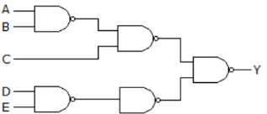**(A’+B’)C+ (DE)’**
7. A’+B’+C’+D’+E’
8. AB+C+DE
9. AB+C(D+E)

Figure -1

1. In the given figure-2, A = B = 1 and C = D = 0. Then Y =
2. 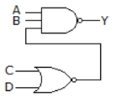**0**
3. 1
4. Either 0 or 1
5. Indeterminate

Figure -2

1. The logic circuit given figure -3 converts a binary code ABC into
2. 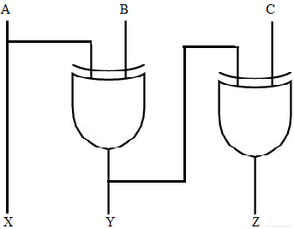Excess-3 Code
3. **Gray Code**
4. BCD code
5. Hamming Code

Figure - 3

1. Which of the following Boolean algebra statements represent distributive law
2. A+BC = A.B + A.C
3. A + BC = A(B+C)
4. A + BC = (A+B).C
5. **A + BC = (A + B) (A + C)**
6. Which one of the following gives the simplified sum of products expression for the Boolean function F = m0 + m2 + m3 + m5, where m0, m2, m3 and m5 are minterms corresponding to the inputs X, Y and Z with X as the MSB and Z as the LSB?
7. **X’Y+ X’Y’Z’+ XY’Z**
8. X’Z’+ XY’+ XY’Z
9. X’Z’+ X’Y+ XY’Z
10. X’YZ+ X’Z’+ XY’Z
11. 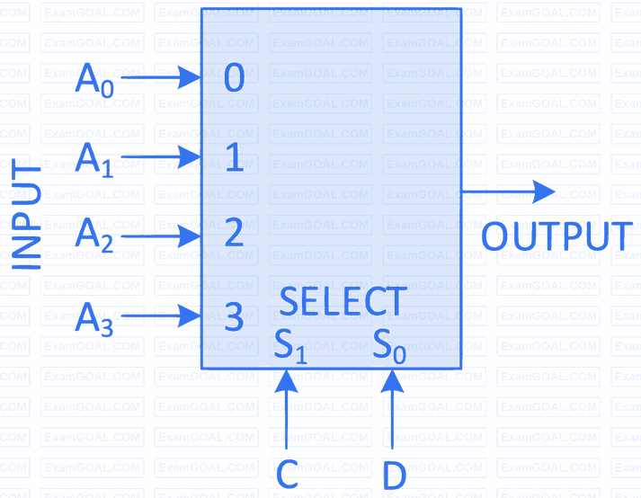Consider the 2-bit multiplexer (MUX) shown in the figure-4. For OUTPUT to be the XOR of C and D, the values for A0, A1, A2 and A3 are ___________.
12. A0 = 0, A1= 0, A2 =1,A3 =1
13. A0 = 1, A1= 0, A2 =1,A3 =0
14. A0 = 0, A1= 1, A2 =1,A3 =0
15. A0 = 1, A1= 1, A2 =0, A3 =0

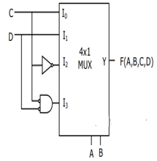 Figure - 4

1. The Boolean function realized by the logic circuit shown figure-5 is
2. F = Σ m( 0,1,3,5,9,10,14)
3. F = Σ m( 2,3,5,7,8,12,13)
4. F = Σ m( 1,2,4,5,11,14,15)
5. **F = Σ m( 2,3,5,7,8,9,12)**

Figure – 5

1. A gated S-R latch and its associated waveforms are shown figure-6. What, if anything, is wrong and what could be causing the problem?
2. 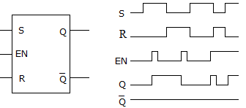**The $\overline{Q }$ output is always low; the circuit is defective**.
3. The $Q$  output should be the complement of the $\overline{Q }$  output; the *S* and *R* terminals are reversed.
4. The *Q* should be following the *R* input; the *R* input is defective.
5. There is wrong with the $Q$ output circuit Figure - 6
6. What is the major difference between half-adders and full-adders?
7. Nothing basically; full-adders are made up of two half-adders.
8. Full adders can handle double-digit numbers.
9. **Full adders have a carry input capability**.
10. Half adders can handle only single-digit numbers.
11. In the latch circuit shown figure-7, the NAND gates have non-zero, but unequal propagation delays. The present input condition is: P = Q = “0”. If the input condition is changed simultaneously to P = Q = "1", the outputs X and Y are
    1. 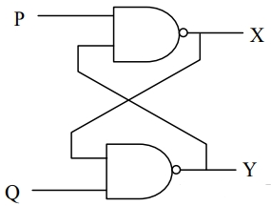X= 1 , Y= 1
    2. **Either X= 0 , Y= 1 or X= 1 , Y= 0**
    3. Either X= 1 , Y= 1 or X= 0 , Y= 0
    4. X= 0 , Y= 0

Figure - 7

1. Which one the following is true about signal and system analysis
2. A system is a set of fixed rules that relates an output time signals to its input signal
3. Usable information is conveyed through signal
4. A shift in the input signal does not exhibit the corresponding shift in the output
5. A system is a mathematical operator which maps input into output
6. Most of the signals found in nature are ________
7. Continuous-time and discrete-time
8. Continuous-time and digital
9. Digital and Analog
10. Analog and Continuous-time
11. If a signal $x(t) u(t)$ is shifted to left side by $t_{0}$,then the function can be expressed as
$x(t – t_{0}) u(t)$

$x(t) u(t – t_{0})$

$x(t – t_{0}) u(t – t_{0})$

$x(t +t_{0}) u(t + t_{0})$

12. When we take up design of systems, ideally how do we define the stability of a system?
13. A system is stable, if a bounded input gives a bounded output, for some values of the input.
14. A system is unstable, if a bounded input gives a bounded output, for all values of the input.
15. A system is stable, if a bounded input gives a bounded output, for all values of the input.
16. A system is unstable, if a bounded input gives a bounded output, for some values of the input.
17. The system 𝑦(𝑡)=𝑥(𝑡)cos (𝑡+1) is
18. Not memoryless and causal
19. Not memoryless and not causal
20. Memoryless and causal
21. Memoryless and not causal
22. Consider a continuous-time system with input $x(t)$ and output y(t) given by $y(t) = x(t)cost$. The system is:
23. Linear and Time-invariant
24. Non-linear and Time-invariant
25. Linear and Time-varying
26. Non-linear and Time-varying
27. The homogeneous solution of the differential equation 𝑑𝑦(𝑡)𝑑𝑡+𝑎𝑦(𝑡)=𝑥(𝑡) will be of



$Ce^{at}$

$C_{1}e^{at}+ C_{2}e^{-at}$

$C_{1}+ C_{2}e^{-at}$

$Ce^{-at}$

32. Two systems with impulse responses $h_{1}(t)$ and $h_{2}(t)$ are connected in cascade. Then the overall impulse response of the cascaded system is given by:
33. Product of $h_{1}(t)$ and $h_{2}(t)$
34. Sum of $h_{1}\left(t\right)$ and $h_{2}(t)$
35. Convolution of $h_{1}(t)$ and $h_{2}(t)$
36. Subtraction of $h_{1}(t)$ and $h_{2}(t)$
37. The result of $u(t) * u(t)$ is, where $u(t)$ is unit step signal:
$u^{2}(t)$

$tu\left(t\right)$

$t^{2}u\left(t\right)$

$δ(t)$

38. Which one of the following is correct on properties of Laplace transform?
$\int_{-∞}^{t}{x\left(τ\right)dτ ↔}\frac{1}{s}X(s)$

$x\left(at\right) ↔ X(s)$

$e^{s_{0}}x\left(t\right) ↔ X(s_{0})$

$\frac{d}{dt}x\left(t\right)↔\frac{1}{s}X(s)$

39. The initial value of $f\left(t\right)$ with Laplace transform $F\left(s\right)= \frac{S+1}{\left(S+2\right)\left(S+3\right)}$ is:
40. Nonexistent
$∞$

41. 0
42. 1
43. The inverse Laplace transform of $F\left(s\right)= \frac{S+2}{{\left(S+2\right)}^{2}+1}$ is:
$e^{-t}cos2t$

$e^{-t}sin2t$

$e^{-2t}sin2t$

$e^{-2t}cos2t$

44. Which one the following is not true about Fourier Series
45. A mathematical tool that allows representation of any periodic signal as the sum of harmonically related sinusoids
46. A shift in time domain is equivalent to introducing phase shift in Fourier Series
47. Odd periodic signals have only sine terms of Fourier Series
48. Compression of a signal in time domain is equivalent to compression in Fourier Series
49. Which of the following cannot be a Fourier series?
$5sint+3sin2t-2sin3t+sin4t$

$Sint-2cos3t+4sin4t+cos4t$

$Sint+3sin2.7t-cosπt+2tanπt$

$1 + e^{-jω} + \frac{e^{-j2πt}}{2}+ \frac{e^{-j3πt}}{3}$

50. In the Fourier transform, if the time domain signal $x(t)$ is real and even, then the frequency domain signal $X(ω)$ will be:
51. Imaginary and even
52. Imaginary and odd
53. Real and Even
54. Real and odd
55. Which of these functions does not have a Fourier transform?
$1/t$

$te^{-3t}u(t)$

$e^{t}u(-t)$

$|t|u(t)$

56. What type of materials is formed when trivalent material is doped with silicon or germanium?
57. N type
58. N and P type
59. PN type
60. P type
61. The term “fully saturation” for a transistor refers to:
62. The collector current at its maximum value.
63. The collector current at minimum value
64. The transistors beta at its maximum value
65. The transistors alpha at its maximum value
66. Common base amplifier has___________compared to common emitter and common collector amplifiers.
67. A higher input resistance
68. A larger current gain
69. A lower input resistance
70. A larger voltage gain
71. In an intrinsic semiconductor which one of the following alternative is true?
72. Free electrons are thermally generated
73. Minority charge carriers are holes
74. Majority charge carriers are holes
75. None
76. How to forward bias a PN junction diode?
77. By applying an external voltage that is positive to the n-region and negative to the p-region
78. By applying an external voltage that is positive to the p-region and negative to the n-region
79. By applying an external voltage that is positive to the cathode and negative to the anode
80. By applying an external voltage that is positive to both anode and cathode
81. Which one of the following is the most unstable biasing technique in basic transistor amplifiers?
82. Limited bias
83. Combination bias
84. Self-bias
85. Base current fixed bias
86. Which of the following rectifier needs a transformer for its operation?
87. half-wave rectifier
88. Centre-tap full-wave rectifier
89. bridge full-wave rectifier
90. none of the above
91. The theoretical maximum efficiency of a Bridge rectifier circuit is
92. 48.2%.
93. 82%.
94. 81.2%.
95. 40.6%.
96. The extremely high input impedance of a MOSFET is primarily due to …..
97. Absence of its channel.
98. Negative gate-source voltage.
99. Depletion of current carriers.
100. Extremely small leakage current of its gate capacitor.
101. In a BJT, if the emitter junction is reverse-biased and the collector junction is reverse-biased, it is said to operate in
102. in active region
103. in saturation region
104. in cut-off region
105. none of the above
106. In a common-emitter transistor amplifier circuit ẞ = 100, input resistance R₁ = 1 kΩ, output resistance R2 = 10 kΩ. The voltage gain of circuit is:
107. 100
108. 1000
109. 10
110. 5000
111. Consider the common emitter amplifier shown below figure with the following circuit parameters:

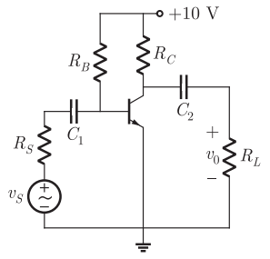Β=100, $g_{m}=0.3861 A/V$, $r_{o}=259Ω$, $R_{s}=1kΩ$, $R_{B}=93kΩ$, $R_{C}=250kΩ$, $R_{L}=1000kΩ$, $C_{1}=∞$ and $C_{2}=4.7μF$.

The lower cut -off frequency due to C2 is

1. 33.9 Hz
2. 27.1 Hz
3. 13.6 Hz
4. 16.9 Hz

Figure 1

1. A half-wave rectifier has an input voltage of 240 V r.m.s. If the step-down transformer has a turns ratio of 8:1, what is the peak load voltage? Ignore diode drop.
2. 27.5 V
3. 86.5 V
4. 30 V
5. 42.5 V
6. With the positive probe on an NPN base, an ohmmeter reading between the other transistor terminals should be:
7. Open
8. infinite
9. low resistance
10. high resistance
11. The gain band width product, thermal stability and the relation between input and output of FET compared to BJT is respectively
12. High, low linear
13. Low, low, non-linear
14. Low, high, linear
15. Low, high, nonlinear
16. What is the typical value for the input impedance Zi for JFETs?
17. 100K OHM
18. 1 M OHM
19. 10 M OHM
20. 1000 M OHM
21. This is an example of the output swing for a class _______________________ amplifier
22. 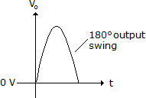A.
23. B.
24. AB
25. C
26. Which of the following is (are) not power amplifiers?
27. Class A
28. Class B or AB
29. Class C or D
30. Feedback amplifier
31. Which one of the following is a component of computer system which manages the entire function of computer system?
32. Memory unit
33. Input /output unit
34. Arithmetic Logic Unit
35. Control Unit
36. Which one of the following is the function of computer that connect all of the components so that they may communicate and work?
37. Mother Board
38. Graphics Processing Unit (GPU)
39. Operating System
40. Central Processing Unit (CPU)
41. In programming a set of instructions or rules designed to solve a given problem with finite number of steps is called?
42. Coding
43. **Algorithm**
44. Implementation
45. Analysis
46. In programming, a function which repeats itself is called?
47. Inline function
48. **Recursive function**
49. Predicate function
50. Faction declaration
51. What will be the output of the following Python code?
52. >>>list1 = [1, 3]
53. >>>list2 = list1
54. >>>list1[0] = 4
55. >>>print(list2)
56. [1, 4]
57. [1, 3, 4]
58. [1, 3]
59. [4, 3]
60. What will be the value of’ list 3 in following Python program?

list1 = [1,2,3,4]

list2 = [2,4,5,6]

list3 = [2,6,7,8]

list1.append(list2)

list1.pop(6)

list3.append(list1[1-6]

print list3

1. [2, 3, 4, 2, 4]
2. [1, 2, 3, 4, 2,4,6]
3. [2, 6, 7, 8]
4. [1, 2, 3, 4]
5. Which of the following statements is wrong about inheritance?
6. Protected members of a class can be inherited
7. The inheriting class is called a subclass
8. Private members of a class can be inherited and accessed
9. Inheritance is one of the features of OOP
10. What will be the output of the following Python code?

def test(i,j):

if(i==0):

return j

else:

return test (i-1, i + j)

print (test(4,7))

1. 13
2. 7
3. Infinite loop
4. 17
5. Which of the following best describes polymorphism?
6. Ability of a class to derive members of another class as a part of its own definition
7. Means of bundling instance variables and methods in order to restrict access to certain class members
8. Focuses on variables and passing of variables to functions
9. Allows for objects of different types and behavior to be treated as the same general type
10. One of the following is characteristics of computer that can perform different kinds of works with same accuracy and efficiency.
11. Versatility
12. Diligence
13. Speed
14. Accuracy
15. Which register holds the address of the current instruction being executed?
16. Instruction register
17. Memory data register (MDR)
18. Stack register
19. Program counter
20. Which of the following is not a valid variable name in most programming languages?
21. Abc123
22. 123abc
23. _abc
24. abc_def
25. One of the following is a program which is used to convert codes of high-level language into machine language and it scan all line at a time?
26. Assembler
27. Interpreter
28. Compiler
29. Debugger
30. Which of the following is used to measure the speed of the CPU (processor)?
31. Processing speed
32. Unit
33. Coprocessor
34. Clock speed
35. What will be the output of the following programming code?

i = 0

while i < 10:

print (i)

i += 2

if i % 3== 0:

break

1. 0 2 4 6
2. 0 2 4
3. 0 2 4 6 8
4. 0 1 2
5. The assignment of more than one function to a particular operator is _______
6. Operator over-assignment
7. Operator overriding
8. Operator instance
9. Operator overloading